4.2 UI / Wireframe Design using Figma

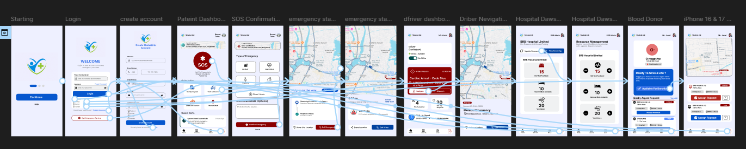
Figure: Wireframe Design

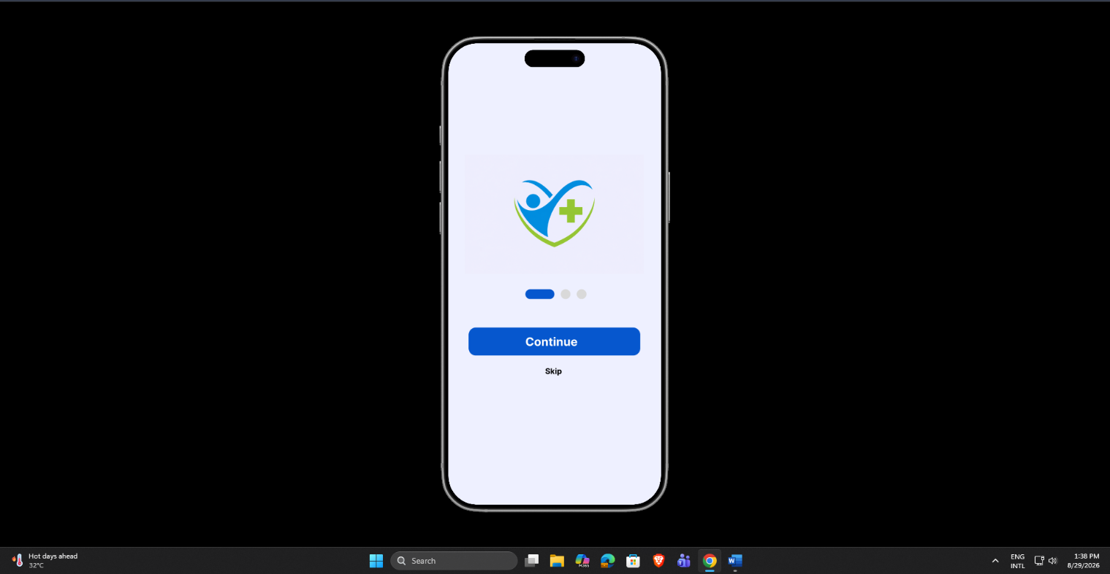
Figure: Loading Page

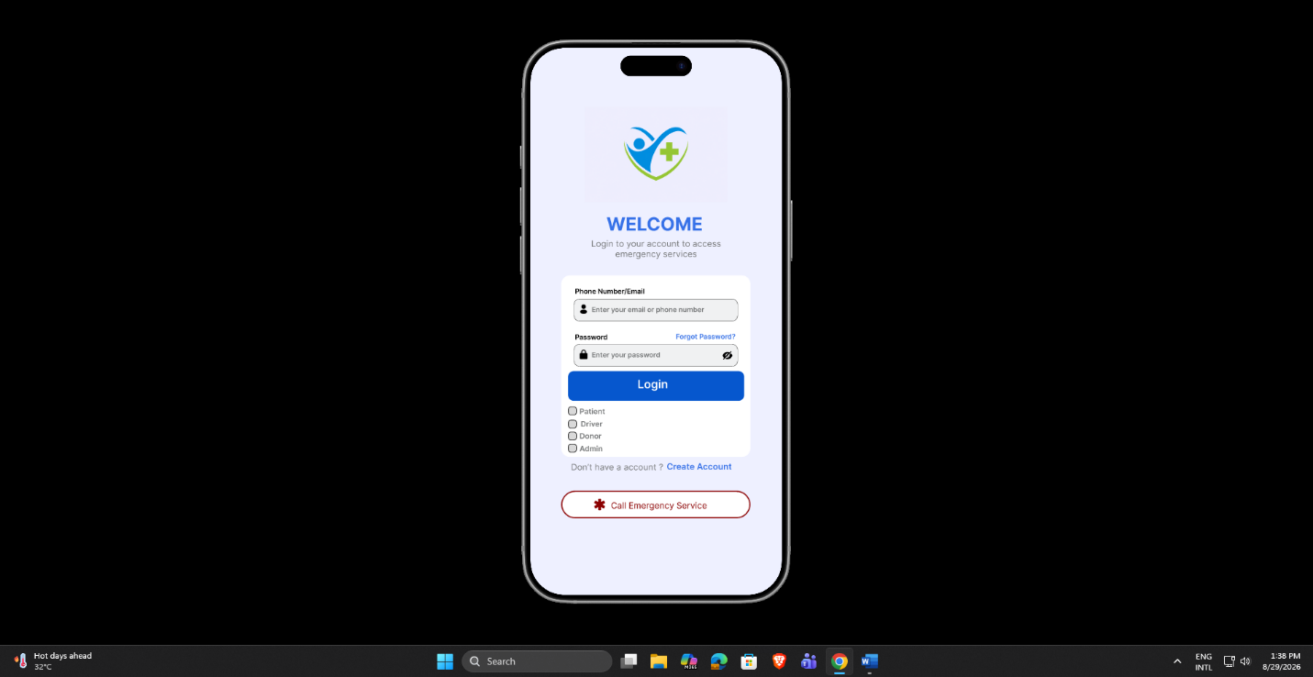
Figure: Login Page

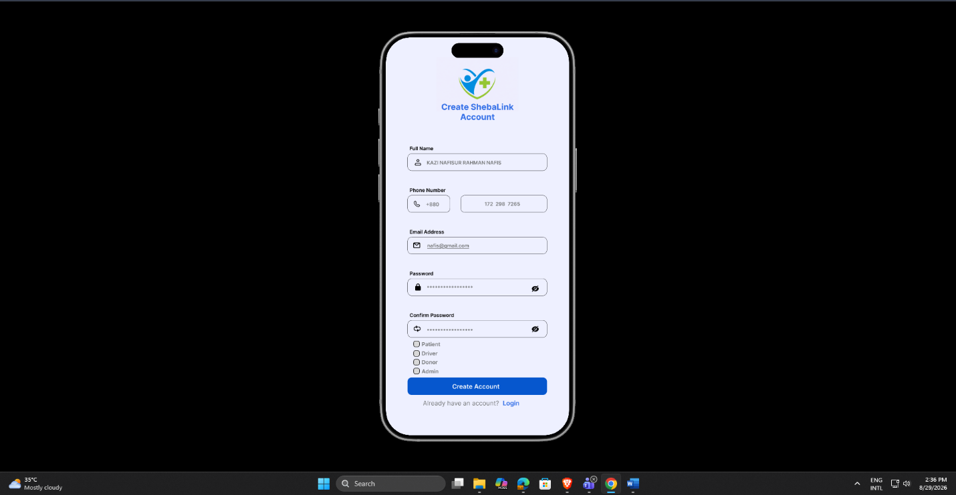
Figure: Create Account Page

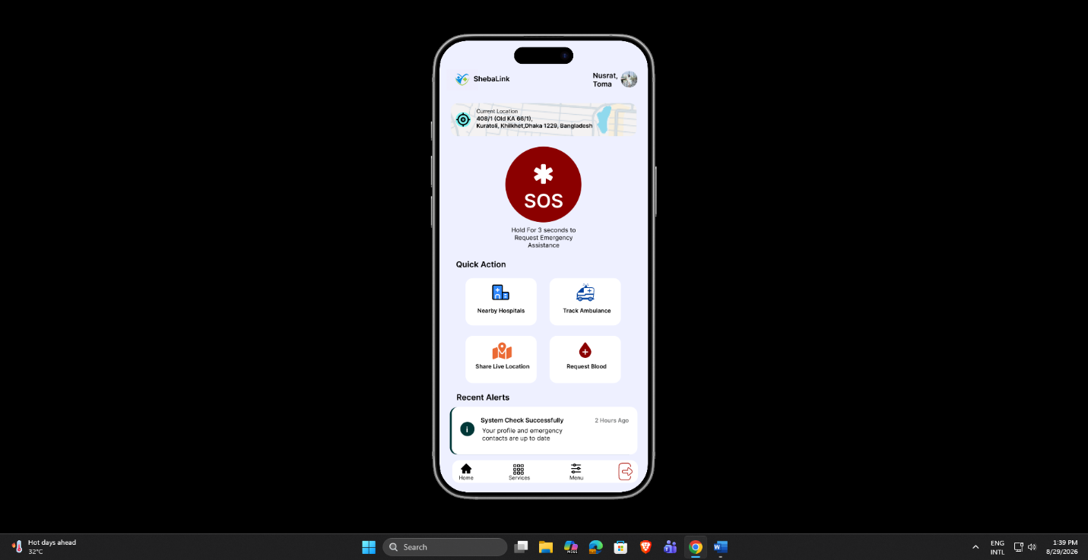
Figure: Patient Dashboard Page
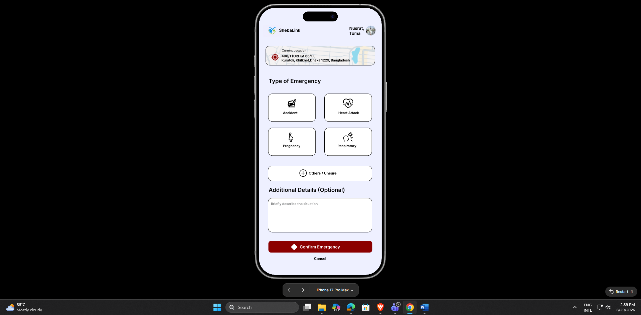
Figure: SOS Confirmation Page

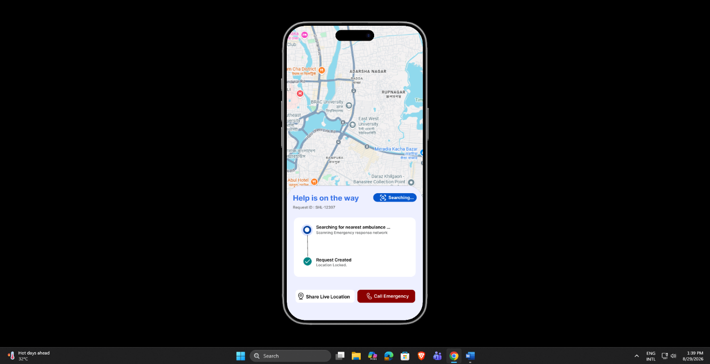
Figure: Emergency Status Page
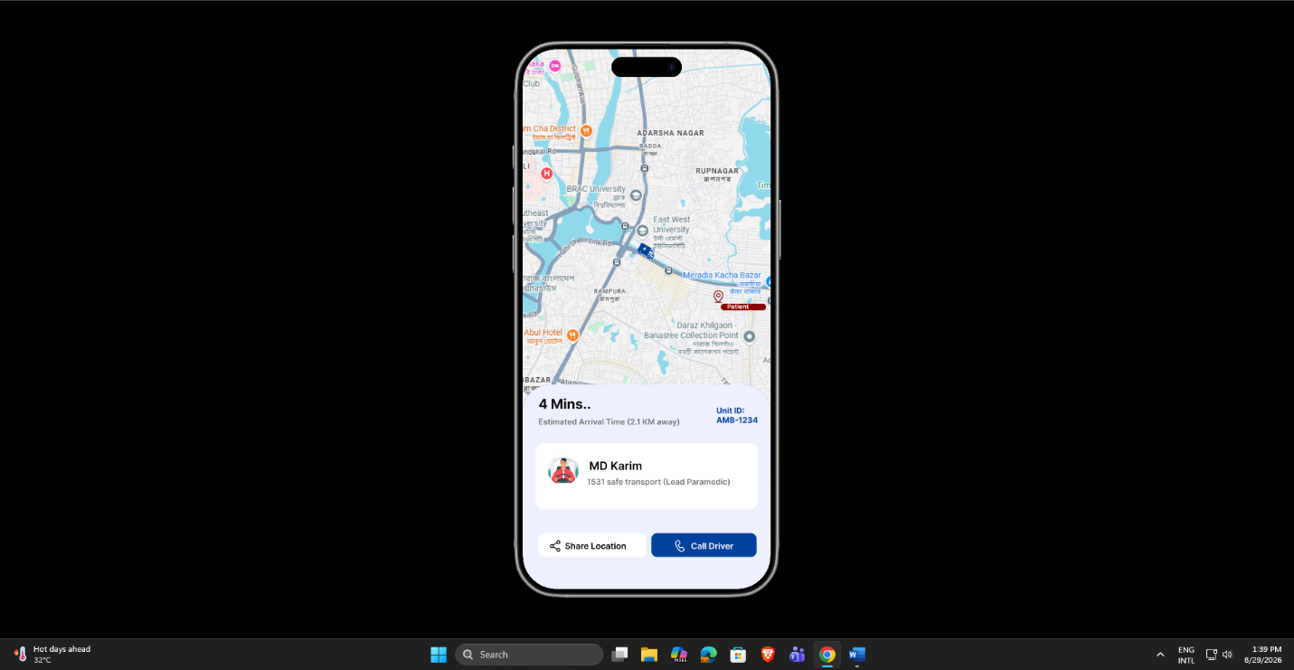
Figure: Track Ambulance Page

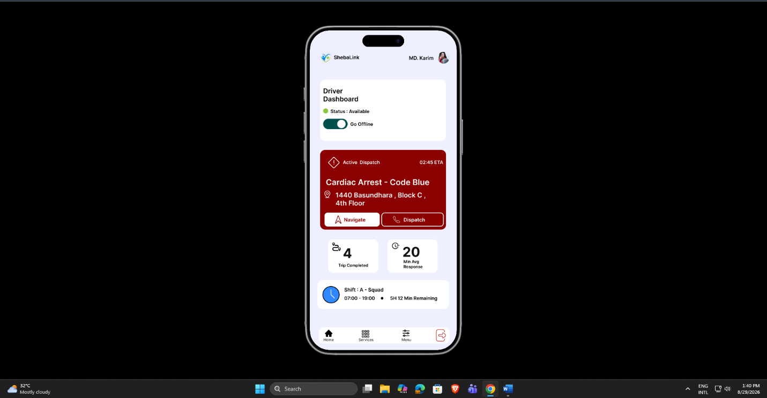
Figure: Driver Dashboard Page

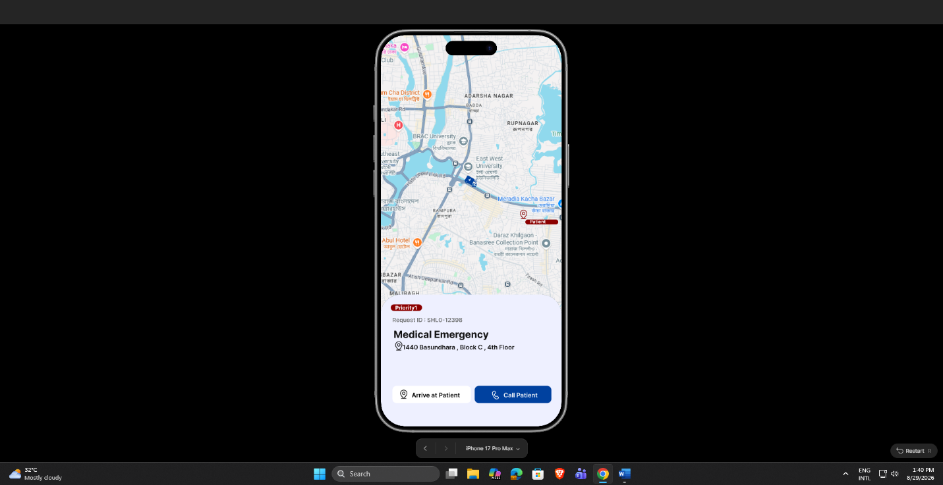
Figure: Driver Navigation Page

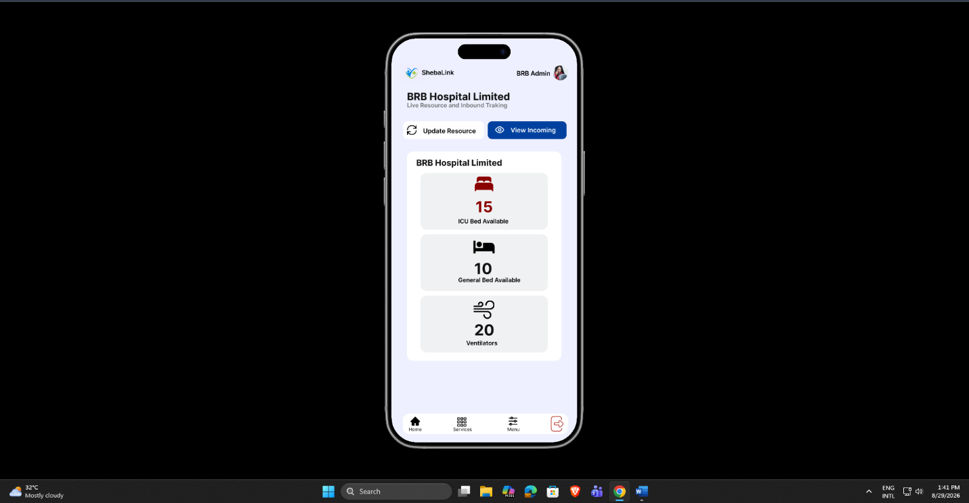
Figure: Hospital Dashboard Page

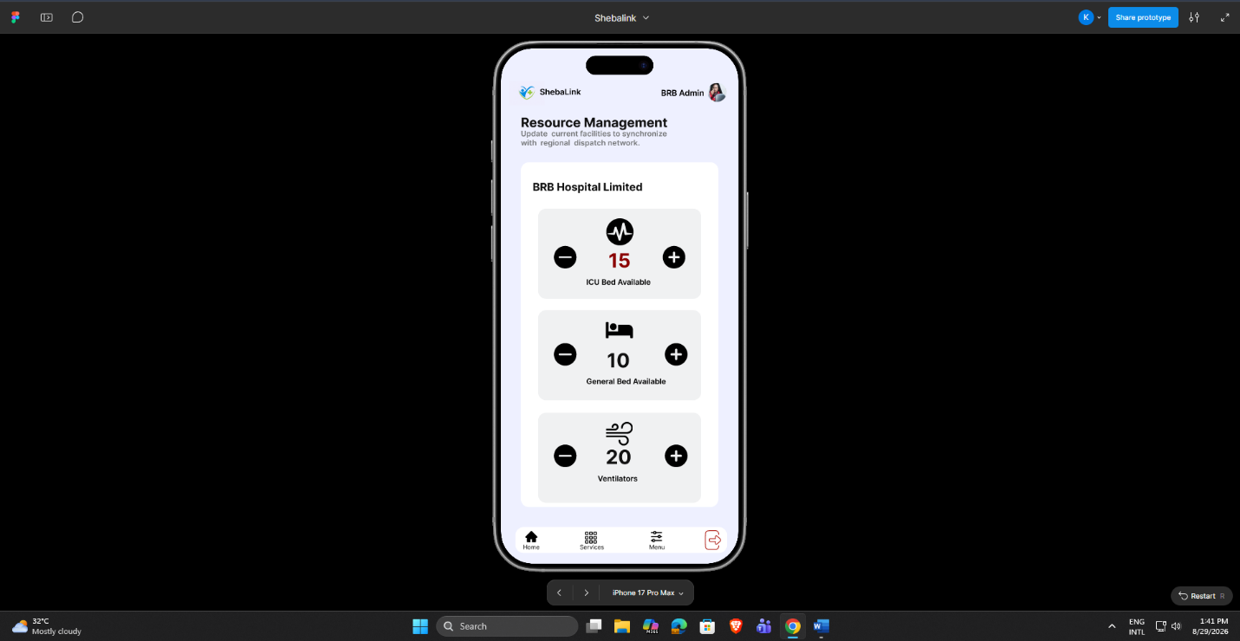
Figure: Hospital Resource Update Page

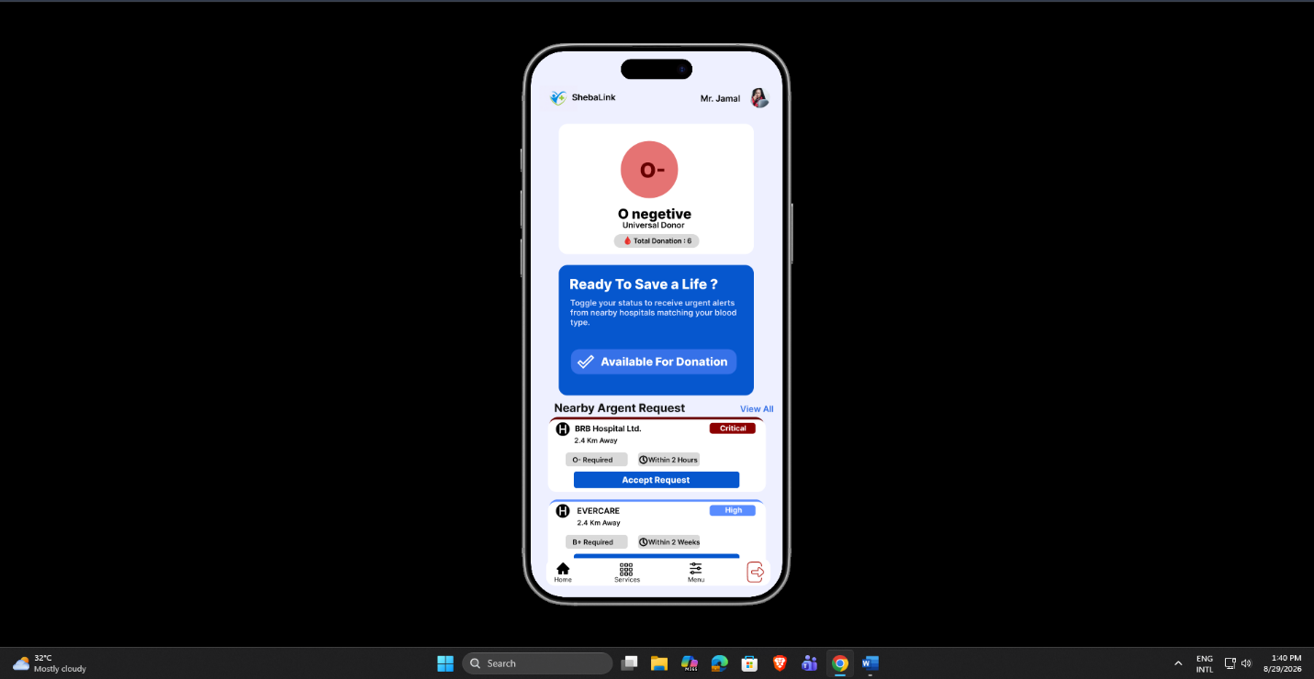

Figure: Donor Dashboard Page

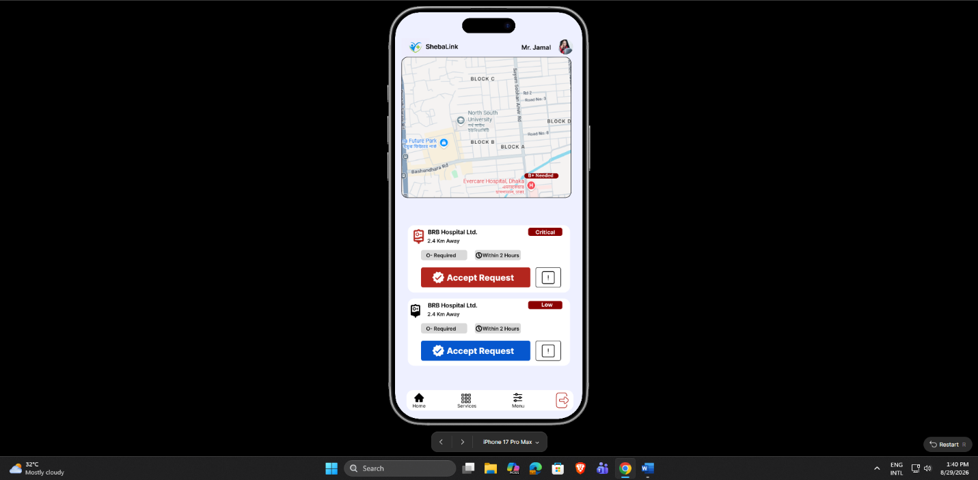
Figure: Donor Nearby Blood Request Page

